**Question 2: (3 marks)**

The given file Q2.py already contains statements to input the integer variable named **n (n>0)**. You should write statements to calculate expression value:

$S\left(n\right)=1+3+5+….+\left(2×n+1\right), n≥$ S(n) = 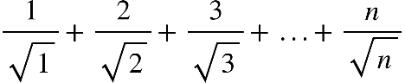

**Notes**:

- *Do not edit given statements in the* ***main*** *function.*

- You can create new functions if you see it is necessary.

- The output result is formatted in two decimal places

**Sample input and output**:

Input: n = 5

After processing: S(5) = 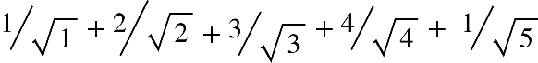 = 8.38

Output for marking:

**OUTPUT:**

8.38